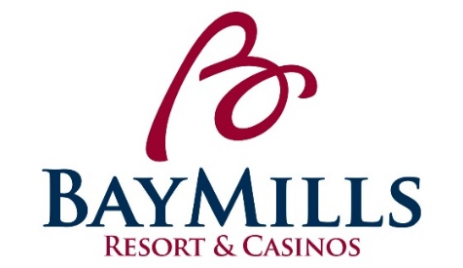
POSITION DESCRIPTION
Bay Mills Resort & Casinos

POSITION: BBGG’s Host(ess) LICENSED: No

DEPARTMENT: Food and Beverage Department GRADE: 9 ($12.45-18.68)

REPORTS TO: F&B Supervisor STATUS: Non-Exempt

POSITION SUMMARY:
Under the direction of the F&B Supervisor, the BBGG’s Host(ess) welcomes and seats all guests of the dining room in a friendly and courteous manner.

ESSENTIAL FUNCTIONS:
- Provides exemplary customer service by “Exceeding Expectations One Opportunity at a Time”.
- Provide fast and courteous service to all guests of the establishment.
- Greets guests in a friendly manner, escorts them to tables, and provides menus.
- Answers and communicates well with people via phone.
- Responds in a timely manner to room service calls.
- Wraps and prepares silverware to par level as well as other assigned side work.
- Ensures that the guests are receiving prompt service at all times.
- Assists other positions in the restaurant when needed and cooperates well with co-workers.
- Collects payment from customers with occasional responsibility for balancing all transactions at the end of each shift
- Enters all transactions into POS system
- Utilizes point-of-sale computer for order entry and guest settlements.
- Responsible for learning and following daily policies and procedures for the F&B Department and Bay Mills Resort & Casinos.
- Must attend all mandatory trainings designated by the Human Resources Department and/or Department Manager.
- Other duties may be assigned within the scope and complexity of this position’s essential functions.

PHYSICAL REQUIREMENTS:
While performing the duties of this job, the employee is regularly required to walk and stand. Requires frequent to continual standing/walking, reaching, bending, and carrying items of up to 25 pounds.

POSITION REQUIREMENTS:
- Must have a high school diploma or equivalent required.
- Must be 18 years of age or older.
- Six months in similar position is desired.
- Prior experience in a guest service position strongly desired.
- Must have excellent communication skills.
- Must have a professional, neat and clean appearance with an outgoing and friendly personality.
- To perform this position successfully, an individual must be able to satisfactorily perform each function listed under the essential functions and physical demands categories of this position description.
- Must have an excellent past work record, including attendance.

PREFERENCE: Preference will be given to those of Native American descent.

CLOSING DATE: OPEN UNTIL FILLED

APPLY TO: Send Resume and/or Application to:

Erin Forrester; HR Generalist
Bay Mills Human Resources Department
12124 W. Lakeshore Drive
Brimley, MI 49715
(906) 248-8526

eforrester@baymills.org
Subject:

**Applications can be found on the Bay Mills website at www.baymills.org under the employment section**

