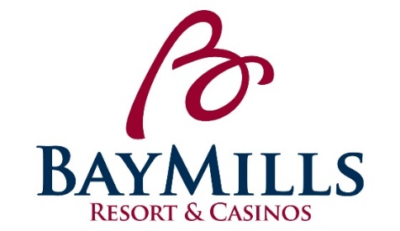
POSITION DESCRIPTION
Bay Mills Resort & Casinos

POSITION: Steward LICENSED: No

DEPARTMENT: Food and Beverage Department GRADE: 9 ($9.45-13.88)

REPORTS TO: Kitchen Supervisor/Kitchen Lead STATUS: Non-Exempt

POSITION SUMMARY:
Under the direction of the Kitchen Lead and the Kitchen Supervisor, the Steward ensures the cleanliness of kitchen area, equipment, utensils, and dishes in a timely manner to contribute to guest satisfaction.

ESSENTIAL FUNCTIONS:
- Provides exemplary customer service by “Exceeding Expectations One Opportunity at a Time”.
- Responsible for cleanliness of dishes, glasses, silverware, pots, pans, utensils, and equipment.
- Scrapes food from dirty dishes and washes them by hand or places them in racks or on conveyor to dishwashing machine.
- Keeps work areas, hallways and walk-in coolers clean by sweeping and mopping, clean surfaces, and emptying garbage containers.
- Ensures the total cleanliness of all kitchen facilities and all storage areas throughout the kitchen.
- Operation of dish machine and cleanliness of all silverware and glassware as well as total upkeep of entire dish area.
- Aiding in all facets of kitchen operations as seen fit by the lead and supervisor.
- Responsible for learning and following daily policies and procedures for the F&B Department and Bay Mills Resort & Casinos.
- Must attend all mandatory trainings designed by the Human Resources Department and/or Department Manager.
- Other duties may be assigned within the scope and complexity of this position’s essential functions.

PHYSICAL REQUIREMENTS:
While performing the duties of this job, the employee is regularly required to walk and stand for extended periods of time. The employee must bend, squat, climb, crouch, kneel, and push/pull. The employee must occasionally lift and/or move up to 75 pounds while frequently lifting and/or moving up to 35 pounds. The employee is regularly exposed to dust and cold when working in the freezer and coolers. The employee is regularly exposed to wet floors, moderate noise, heat and cold. The employee may experience cuts, burns, sprains and strains.

POSITION REQUIREMENTS:
- High school diploma or equivalent desired.
- Must be able to work closely with all fellow employees under all circumstances and adverse conditions.
- Must be able to take direction well.
- Must possess a personable, customer service attitude along with organizational ability to handle multiple tasks simultaneously.
- To perform this position successfully, an individual must be able to satisfactorily perform each function listed under the essential functions and physical demands categories of this position description.
- Must have an excellent past work record, including attendance.

PREFERENCE: Preference will be given to those of Native American descent.

CLOSING DATE: Open Until Filled

APPLY TO: Please email application and resume to Erin Forrester, HR Generalist at eforrester@baymills.org
Subject: Steward

*Applications can be found at www.baymills.org under “employment opportunities”

