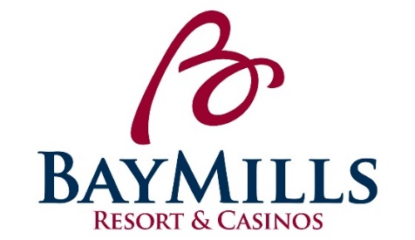
POSITION DESCRIPTION
Bay Mills Resort & Casinos

POSITION: Convention Sales Coordinator LICENSED: No

DEPARTMENT: Food and Beverage Department GRADE: 6

REPORTS TO: F&B Operations Manager STATUS: Exempt

POSITION SUMMARY:
Under the direction of the F&B Operations Manager, the Convention Sales Coordinator may work closely with the Marketing team to ensure that Horizon’s Conference Center events are efficiently scheduled, staffed, decorated and thoroughly cleaned in a timely manner.

ESSENTIAL FUNCTIONS:
- Provides exemplary customer service by “Exceeding Expectations One Opportunity at a Time”.
- Responsible for the planning and coordination of all conference activities.
- Responsible for the training and staffing of conference staff.
- Assist with the coordination and communication of group/conference requirements and needs with other departments and their staffs.
- Provide Sales Department’s room layout to F&B managers and maintenance when requested.
- Responsible for providing final count to F&B managers.
- Plan, coordinate, and interface conference/group activities for client with other in-house departments.
- Responsible for follow-up on conference room preparation: conference room sign prepared as requested, floor plan as required, audio-visual equipment in place, food, bar etc..
- Follow-up on set-up and function completion to make sure it is correct. Be present before function and at least an hour after function begins, if not able to be present—make sure that an F&B manager, banquet captain, or sales staff is present to ensure correct and timely set-up of function as directed by Back Bay manager.
- Work directly with the conference center reservation CATEREASE system. Invoice and process billing in CATEREASE after function is completed as needed.
- Develop relationships with local decorators, DJ’s, cake suppliers, etc.
- Responsible for learning and following daily policies and procedures for the F&B Department and Bay Mills Resort & Casinos.
- Must attend any and all mandatory trainings offered through the Bay Mills Human Resources Training Department, including TIPS.
- Other duties may be assigned within the scope and complexity of this position’s essential functions.

PHYSICAL REQUIREMENTS:
While performing the duties of this job, the employee is regularly required to sit with occasional standing and walking. Occasionally the employee must bend, balance, squat, kneel, push/pull, and crouch. The employee is occasionally required to use hands for firm manipulation and reach with hands and arms above shoulder level. The employee must be able to lift, move, and/or carry up to 25 pounds.

POSITION REQUIREMENTS:
- Must have a high school diploma or equivalent.
- Associate’s Degree in Business preferred.
- Must have a minimum of two years hospitality and/or casino experience in the industry.
- Excellent computer skills required; must have experience using Microsoft Excel, Word, knowledge and experience with CATEREASE, and Opera or the willingness to learn.
- Excellent verbal and written communication skills required.
- Must possess a personable, customer service attitude along with organizational ability to handle multiple tasks simultaneously. Must be team oriented.
- Must present a well-groomed, professional appearance and speak, understand and write in the English language.
- Must be willing to work flexible schedule, some weekends, evenings and/or holidays.
- To perform this position successfully, an individual must be able to satisfactorily perform each function listed under the essential functions and physical demands categories of this position description.
- Must have an excellent past work record, including attendance.

PREFERENCE: Preference will be given to those of Native American descent.

CLOSING DATE: Open Until Filled

APPLY TO: Please email application and resume to Erin Forrester, HR Generalist at eforrester@baymills.org
Subject: Convention Sales Coordinator

*Applications can be found at www.baymills.org under “employment opportunities”

