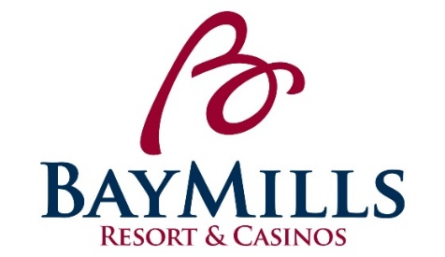
POSITION DESCRIPTION
Bay Mills Resort & Casinos

POSITION: Line Cook (BBGG’s) LICENSED: No

DEPARTMENT: Food and Beverage Department GRADE: 16 ($11.00-16.50)

REPORTS TO: Kitchen Supervisor/Kitchen Lead STATUS: Non-Exempt

POSITION SUMMARY:
Under the direction of the Kitchen Lead and the Kitchen Supervisor, the Line Cook ensures the production of quality food in a timely manner to ensure complete guest satisfaction in all Bay Mills Resort & Casinos kitchens. Must be able to work under direct supervision and alongside fellow employees while keeping in mind teamwork is an essential part of your everyday operations.

ESSENTIAL FUNCTIONS:
- Provides exemplary customer service by “Exceeding Expectations One Opportunity at a Time”.
- Responsible for reporting to work area on time in proper uniform.
- Ensures that all standards regarding food safety, safe product handling and physical plant are prepared and presented per established standards.
- Works cohesively with wait staff to deliver food orders in timely fashion and according to recipe specifications.
- Responsible for adequately stocking work station per levels determined by leadership.
- Prepares cooking ingredients by washing and chopping vegetables, cutting meat, etc.
- Label and stock all ingredients on shelves in an organized matter.
- Measures ingredients to be used in cooking per leadership/recipe specifications.
- Assists with food and/or beverage testing to ensure satisfaction with their selections.
- Ensure all food and other items are stored properly.
- Responsible for changing and rotation of food pans to ensure freshness.
- Utilizing temperature devices to establish proper hot-holding and cold-holding temperatures.
- Responsible for demonstrating safety with all operating equipment.
- Maintain an orderly kitchen by washing dishes, sanitizing surfaces, removing trash, etc.
- Maintains cleanliness and sanitation levels of kitchen production areas and dining serving areas to Inter-Tribal Council required ratings at all times.
- Communicates observed needs for repair of equipment with leadership.
- Responsible for learning and following daily policies and procedures for the F&B Department and Bay Mills Resort & Casinos.
- Attends all mandatory trainings designated by the Human Resources Department and/or immediate Supervisor.
- Other duties may be assigned within the scope and complexity of this position’s essential functions.

PHYSICAL REQUIREMENTS:
While performing the duties of this job, the employee is regularly required to stand for extended periods of time. The employee must bend, squat, climb, crouch, kneel, and push/pull. The employee must occasionally lift and/or move up to 100 pounds while frequently lifting and/or moving up to 75 pounds. The employee is regularly exposed to dust and cold when working in the freezer and coolers. The employee is regularly exposed to marked changes in temperature and humidity and moving machinery, moderate noise, heat, cold, smoke and hot surfaces involved in cooking food, grease and dirty surfaces, use of caustic chemicals. The employee may experience cuts, burns, sprains and strains.

POSITION REQUIREMENTS:
- High school diploma or equivalent required.
- Experience in kitchen operations desired.
- Knowledge of health and safety rules in a kitchen.
- Ability to operate cutting tools and kitchen utensils
- A team player with good communication skills.
- Must be able to remain positive under pressure with ability to handle multiple tasks simultaneously.
- Must present a well-groomed, professional appearance.
- Must be able to speak, understand and write in the English language.
- To perform this position successfully, an individual must be able to satisfactorily perform each function listed under the essential functions and physical demands categories of this position description.
- Must have an excellent past work record, including attendance.

PREFERENCE: Preference will be given to those of Native American descent.

CLOSING DATE: Open Until Filled

APPLY TO: Please email application and resume to Erin Forrester, HR Generalist at eforrester@baymills.org
Subject: BBGG’s Line Cook

*Applications can be found at www.baymills.org under “employment opportunities”

