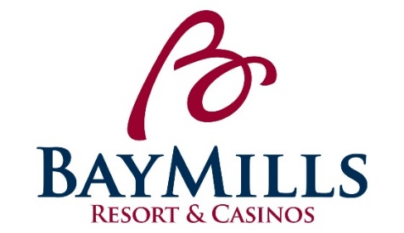
POSITION DESCRIPTION
Bay Mills Resort & Casinos

POSITION: Dealer V LICENSED: Yes

DEPARTMENT: Gaming Department GRADE: 1-5

REPORTS TO: Pit Boss/Pit Boss II STATUS: Non-Exempt

POSITION SUMMARY:
Under the close supervision of the Pit Boss/Pit Boss II, the Dealer is responsible for dealing any or all of the house games in a friendly and courteous manner. Dealer must also report any information need by the Pit Boss concerning the game and customers.

ESSENTIAL FUNCTIONS:
- Provides exemplary customer service by “Exceeding Expectations One Opportunity at a Time”.
- Dealer I- Assumes responsibility for dealing 6-Deck Blackjack.
- Dealer II- Assumes responsibility for dealing 6-Deck Blackjack, Ultimate Texas Hold Em, Three Card Poker, and Let It Ride Poker.
- Dealer III- Assumes responsibility for dealing 6-Deck Blackjack, Ultimate Texas Hold Em, Three Card Poker, Let It Ride Poker, Poker, and 2-Deck Blackjack.
- Dealer IV- Assumes responsibility for dealing 6-Deck Blackjack, Ultimate Texas Hold Em, Three Card Poker, Let It Ride Poker, Poker, 2-Deck Blackjack and Roulette.
- Dealer V- Assumes responsibility for dealing 6-Deck Blackjack, Ultimate Texas Hold Em, Three Card Poker, Let It Ride Poker, Poker, 2-Deck Blackjack, Roulette, and Craps.
- Reports and relays information to Pit Boss or other supervisors any relevant information pertaining to Title 31.
- Works with management to resolve customer complaints.
- Assumes responsibility as the first line of security for game protection against theft and deceit by patrons.
- Acts in a manner, which is kind, courteous, and tactful towards all customers at all times.
- Assists with verifying game fills and credits.
- Assists with table and card game opening and closing procedures.
- Responsible for learning and following daily policies and procedures for the Gaming Department and Bay Mills Resort & Casinos.
- Must attend all mandatory trainings designated by the Human Resources Department and/or Department Director, including TIPS and Title 31.
- Performs and ensures compliance with the Bay Mills Gaming Commission Rules and Regulations.
- Other duties may be assigned within the scope and complexity of this position’s essential functions.

PHYSICAL REQUIREMENTS:
While performing the duties of this job, the employee is regularly required to stand with occasional walking and sitting. Occasionally the employee must bend, squat, crouch, push/pull, and kneel. The employee is frequently required to use hands for simple manipulation and reach with hands and arms. The employee must occasionally lift and/or move up to 25 pounds.

POSITION REQUIREMENTS:
- Must have a high school diploma or equivalent.
- Must have previous dealing experience or training.
- Must be certified by Bay Mills Resort & Casino required table/card games.
- Must be able to obtain a gaming license through the Bay Mills Gaming Commission and maintain eligibility throughout employment.
- Must possess a personable, customer service attitude along with organizational ability to handle multiple tasks simultaneously.
- Must present a well-groomed, professional appearance and speak, understand and write in the English language.
- Excellent communication skills required.
- To perform this position successfully, an individual must be able to satisfactorily perform each function listed under the essential functions and physical demands categories of this position description.
- Must have an excellent past work record, including attendance.

PREFERENCE: Preference will be given to those of Native American descent.

CLOSING DATE: Open Until Filled

APPLY TO: Please email application and resume to Erin Forrester, HR Generalist at eforrester@baymills.org
Subject: Dealer V

*Applications can be found at www.baymills.org under “employment opportunities”

